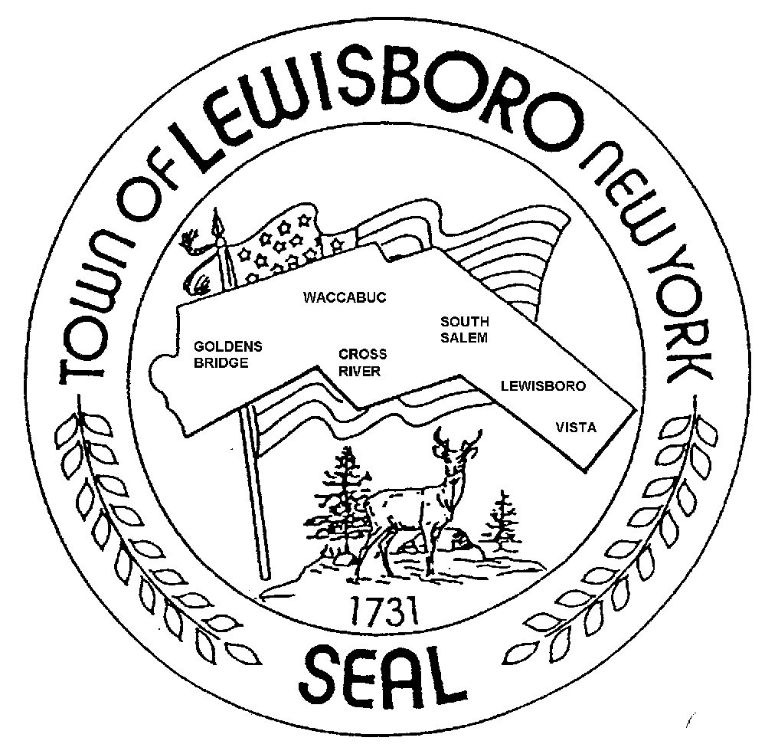

TOWN OF LEWISBORO
Westchester County, New York

Comprehensive Plan Steering Committee Tel: (914) 763-5592
79 Bouton Road Fax: (914) 875-9148
South Salem, New York 10590 Email: steering@planlewisboro.com

COMPREHENSIVE PLAN STEERING COMMITTEE

AGENDA

Thursday, February 23, 2023 7:30 pm- 9:00pm Via Zoom videoconferencing

For Public: https://www.youtube.com/user/LewisboroTV

For Committee: Link to Follow

- WELCOME REMARKS, Committee Chair (7:30pm – 7:35pm)

- PROJECT UPDATE, NPV (7:35 pm – 7:45 pm) NPV

- 7:30 pm – 7:45 pm: Summary of Round 1 public meetings participation
  - Participation totals
  - Participation expectations/comparative comments
- COMMITTEE BUSINESS (7:45 pm – 9:00 pm)

- 7:45 – 8:45pm: Project planning
  - Project schedule
  - Outreach/advertising efforts to date
  - Brainstorm additional outreach/advertising methods
  - Round 2 public meetings – formats, day of week/times
- 8:45 – 9:00pm: Next steps
  - Posting of public input summary, recordings of virtual meetings
  - Review and update open action items (see next page)
  - Outstanding questions for NPV
- NEXT MEETING DATE: March 20, 2023 - 7:30PM via Zoom

- ADJOURN MEETING

Summary of open action items as of February 2022
Follow up by |  | Timeline
All | Submit feedback on draft Inventory & Analysis Report by February 15, 2023 | February 15 - COMPLETE
Need volunteer  (Board liaisons?) | New resident social, February 26, 2023 – Volunteer to attend/share information | February 26
J Wolff | Library volunteer fair, March 4, 2023 – John to coordinate informational table | March 4
K McGinn | Presentation to Town Board, Monday, March 13, 2023  Comprehensive Plan Project Update and Community Outreach and Engagement Plan overview | March 13
NPV | Alert Steering Committee of Grant opportunities | Ongoing
K McGinn | Coordinate Community Outreach Teams | Ongoing
K McGinn | Coordinate outreach/advertising methods and materials | Ongoing
K McGinn | Develop/update content for the Committee’s page on the Town website | Ongoing
C Conran | Coordinate continued updating of email addresses for stakeholder list/Constant Contact mailing list | Ongoing

