Interactive maps for 5 Town Preserves...
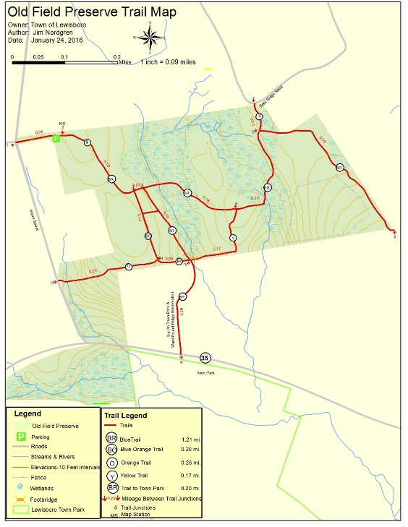
Lewisboro Land Trust has been working on this for a long time, and is very excited to announce that, in addition to the printable trail maps, interactive trail maps are now available for Brownell Preserve, Indian Brook Assemblage, Mt. Holly Sanctuary, Old Field Preserve, and Onatru Park & Preserve. (Leon Levy Preserve will be added next week.) So if you are ever worried you might take a wrong turn while exploring a new trail, these fully-interactive maps, that use your phone's built-in GPS, will show you exactly where you are on the trail. No internet needed. Follow these directions to get started:
Instructions for Android phones:
1. Go to the “Play Store”
2. Search for “Avenza PDF Maps”
3. Download and install “PDF Maps” (free)
4. Open the App
5. Click on the Cart Symbol
6. Tap “Find Maps”
7. Search for “Lewisboro Land Trust” and the list of Lewisboro Trail Maps will appear
8. Click on “List”
9. Choose and install desired map(s)
When you go to the preserve, open app and click on the map for that preserve. A blue dot will find your location and will follow you along the trails.
Instructions for iPhones:
1. Download Avenza/PDF maps app from your app store. It is free.
2. Open the Avenza app on your phone and click Maps at the bottom.
3. Click the PLUS sign (+) or “Find maps” or “PDF maps store” (depending on your device)
4. At top, type in Lewisboro Land Trust and then click on “list”
5. All maps will appear. Click to install desired map(s)
When you go to the preserve, open app and click on the map for that preserve. A blue dot will find your location and will follow you along the trails.
For more step-by-step instructions, go to: avenzamaps.com, scroll down to icon that says “Get the app” and click on “See how it works."
As other maps become available, they will be listed under Lewisboro Land Trust and free to download.

